Assignment 13.2

Name: Guangsinlung Phaomei
Enrollno: 2503a51l20
Batch19

Task Description #1 – Remove Repetition
Task: Provide AI with the following redundant code and ask it to
refactor.
Python Code
def calculate_area(shape, x, y=0):
if shape == "rectangle":
return x * y
elif shape == "square":
return x * x
elif shape == "circle":
return 3.14 * x * x

Prompt1: Refactor the given redundant python code.

Output: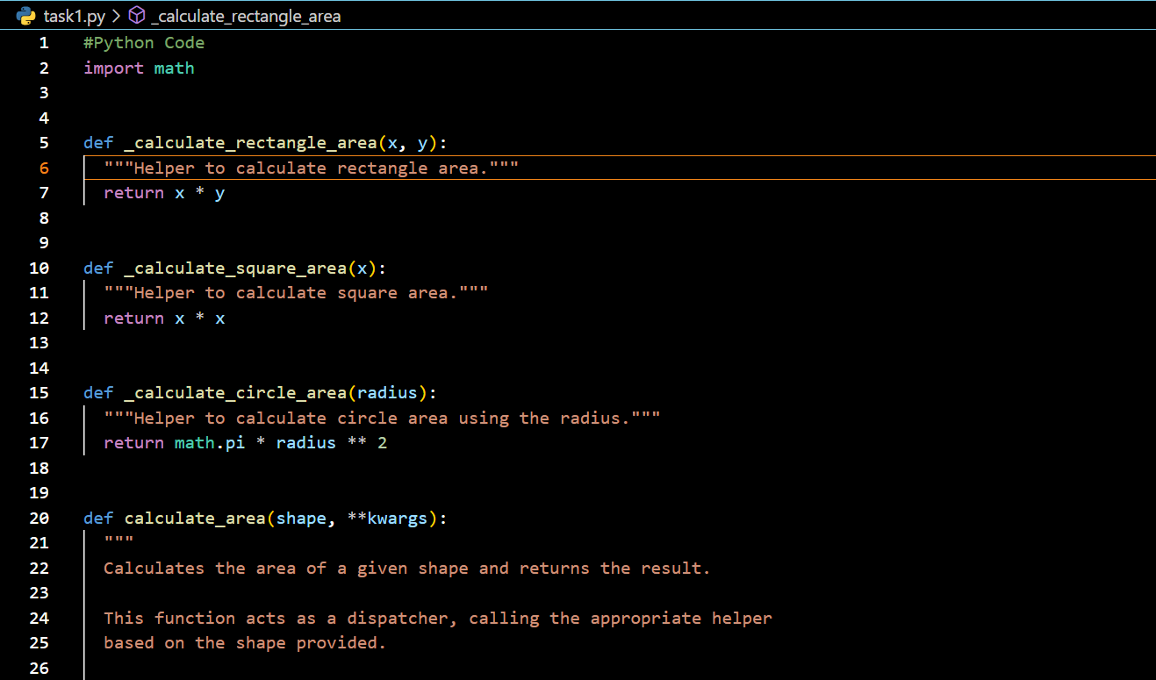
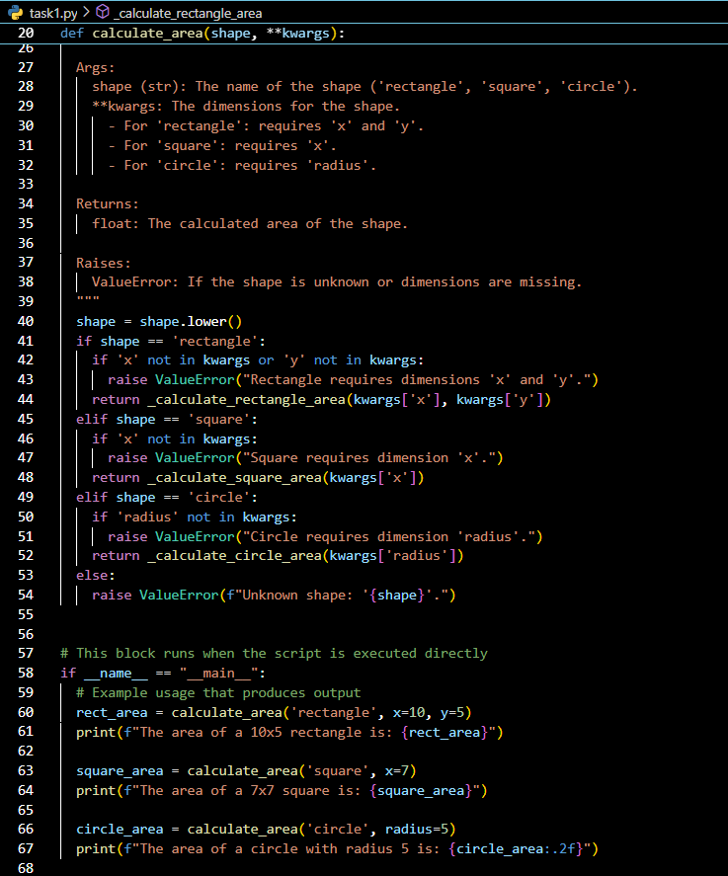

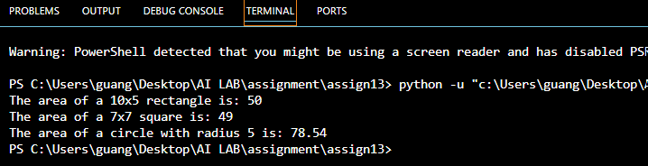

Observation:
The code repeats shape checks with if-elif. Refactoring using a dictionary or separate functions removes redundancy, makes it cleaner, and easier to extend.

Task Description #2 – Error Handling in Legacy Code
Task: Legacy function without proper error handling
Python Code
def read_file(filename):
f = open(filename, "r")
data = f.read()
f.close()
return data
Prompt: Refactor this file-reading function to use with open() for safer file handling and add proper try-except error handling
Output:
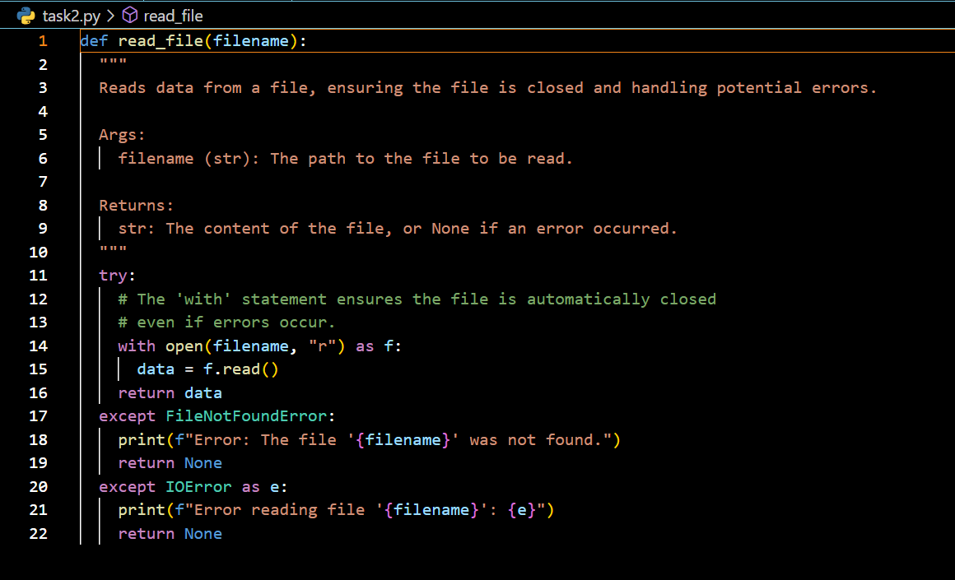

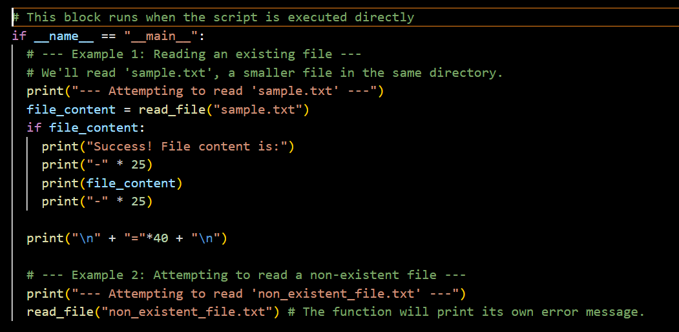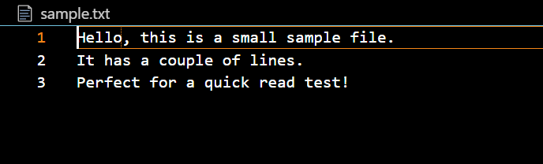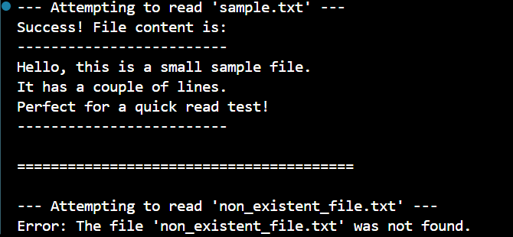
Observation:
The legacy code doesn’t handle exceptions and uses manual file closing. Refactoring with with open() ensures safe file handling, and adding try-except improves robustness.

Task Description #3 – Complex Refactoring
Task: Provide this legacy class to AI for readability and modularity
improvements:
Python Code
class Student:
def __init__(self, n, a, m1, m2, m3):
self.n = n
self.a = a
self.m1 = m1
self.m2 = m2
self.m3 = m3
def details(self):
print("Name:", self.n, "Age:", self.a)
def total(self):
return self.m1+self.m2+self.m3

Prompt:
Improve this Student class by using descriptive variable names, storing marks in a list, adding docstrings, and making methods more readable and modular.
Output: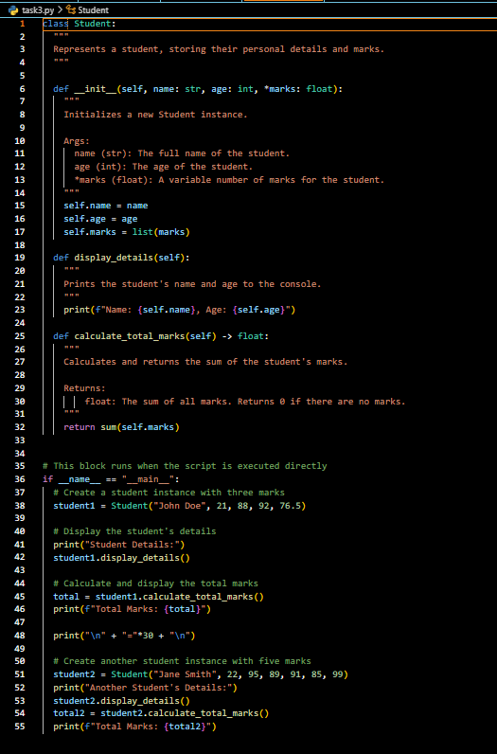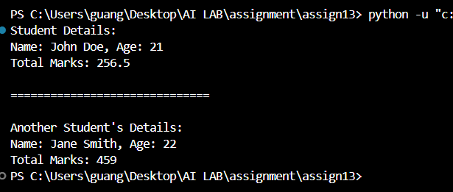

Observation:
The class uses unclear variable names (n, a, m1), lacks documentation, and prints in a less readable format. Refactoring enhances readability with name, age, marks, adds docstrings, and simplifies total calculation with sum(self.marks).

Task Description #4 – Inefficient Loop Refactoring
Task: Refactor this inefficient loop with AI help
Python Code
nums = [1,2,3,4,5,6,7,8,9,10]
squares = []
for i in nums:
squares.append(i * i)
Expected Output: AI suggested a list comprehension

Prompt: Refactor this loop that builds a squares list into a Pythonic one-liner using list comprehension.

Output:
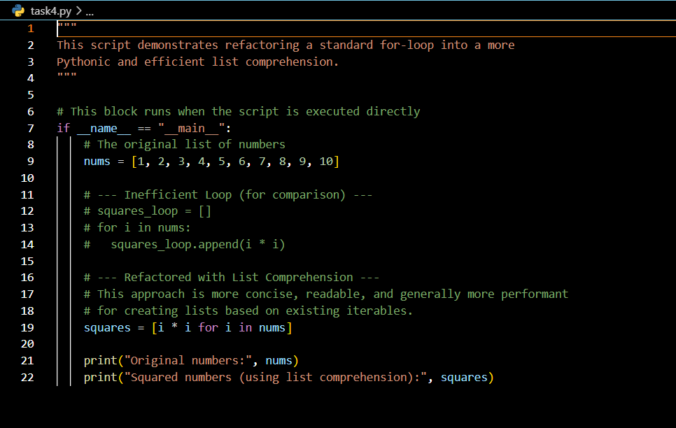

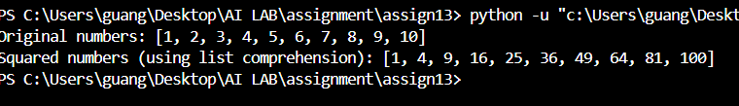

Observation:
The original code uses a verbose for loop with append(). A list comprehension ([i*i for i in nums]) is more concise, efficient, and follows Python best practices.

